**SHRI GURU TEG BAHADUR JI GOVT COLLEGE, TARAORI (KARNAL)**

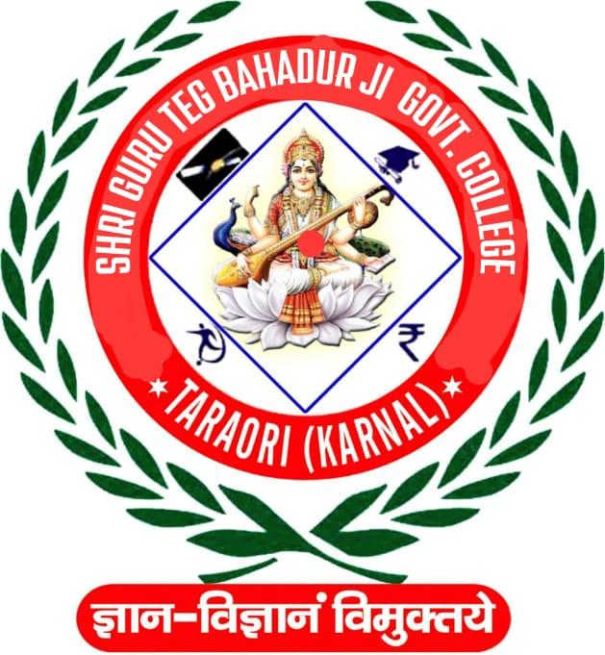

**INSTITUTIONAL DEVELOPMENT PLAN**

**(IDP)-2025**

**Submitted to**

Department of Higher Education, Haryana

**General Profile of the College**

* **Name of the College:** Shri Guru Teg Bahadur JiGovt College, Taraori
* **Year of Establishment:** 2018
* **Name Of Affiliating University:** Kurukshetra University, Kurukshetra
* **Type of Institution:** Co-education
* **Regulatory body approving the institution** Director Higher Education, Haryana
* **Type of Institution(Govt. /Govt. aided)** Government
* **Name of Head of the Institution** Sh Chaman Lal (Principal)
* **NEP Nodal officer** Dr. Rajiv Kumar (Assistant Professor)
* **Date of Establishment of IQAC** July, 2018
* **Details of UGC recognition:**

| **Under Section** | **Date, Month & Year** |
| --- | --- |
| i. 2 (f) | Need to Apply |
| ii. 12 (B) | Need to Apply |

* **Accreditation Detail: Nil**

| **Cycle** | **Grade** | **CGPA** | **Year of Accreditation** | **Validity** | |
| --- | --- | --- | --- | --- | --- |
| **Period From** | **Period**  **To** |
| 1 |  |  |  |  |  |
| 2 |  |  |  |  |  |

**Vision**:

Our vision is to set the standard of excellence for rural students’ education and make the institute a model rural college. An idea of equality and integrity is implicit in everything we do, and we are dedicated for attainment of our goals through the hard work we do, both in teams and as individuals.

Courses will be underpinned by the best teaching, research and support for learning to meet the needs of rural, ambitious and intellectually curious students. Our staff and students will work together with in the college and beyond its precinct to foster a lively and vibrant intellectual community sensitive to the idea of social justice.

**Mission**

We intend to inspire students regionally and nationally by providing quality education to take leading roles in the nation building process. We have strong belief in the idea of social justice and aspire to work in tandem with the entire stake holders to ensure that all our efforts leads to the establishment of the idea of justice.

**Introduction**

United Nation being the world body has set some lofty ambitions for the member states in the form of sustainable development goals. One of the important objectives of the 2030 Agenda for Sustainable Development goals is global education. India being the responsible member of that organization has adopted these goals. It seeks to “ensure inclusive and equitable quality education and promote lifelong learning opportunities for all” by 2030. To achieve this goal, it is recommended that the whole education system is reformed to support and foster learning so that all the critical targets and goals of the 2030 Agenda for Sustainable Development are achieved.

In this direction, the Government of India has been working to recalibrate and reformulate the existing National Policy on Education 1986 as National Education Policy 2020 (NEP 2020). For ages, education has been a tool for the progress of humanity and civilizations. It has morphed human beings in their entirety. In contemporary times, the goal of education is the “all-round development of the human race. It is important for human beings to be able to have rational thought, compassion, courage, and resilience along with scientific temperament. National Education Policy 2020 is the right step in that direction. It intends to bring a revolutionary change in the existing educational framework that is running on decades-old provisions. NEP 2020 provides a flexible approach to the HEIs, where they can formulate their action plans according to their strengths. Having an Institutional Development Plan is an integral part of that policy. The Institutional Development Plan is an important step towardthe implementation of the comprehensive National Education Policy. This draft outlines the detailed action plan discussed and validated by the academic committee of the institution.

**About the college**

Shri Guru Teg Bahadur Ji Government College, Taraori, Karnal affiliated with Kurukshetra University, Kurukshetra was established in 2018 with the aim to impart and foster quality education. Its building is under construction and the institute is currently running in Lalita Shastri School, Nilokheri, Karnal on a Make-Shift arrangement. Despite this, it is striving to pursue excellence in science, arts, humanities, social science, and sports. The college supports excellence and innovation in academic programs, scholarship,and teaching. The hired campus has IT-enabled computer laboratories, science laboratories, andan NSS unit. The academic institute on the campus has thirteen departments and works round the clock to deliver better-quality education for at least 180 days in a year.

**Strength**

1. Sufficient area* with 11 acres of land for future growth of the institution.

2. Dedicated teaching and non-teaching staff.

3. Wide variety of students from a variety of social groups.

4. Achievements in sports and cultural activities.

5. A vibrant NSS Wing.

6. Easy accessibility and well connectivity of the institution as the college is situated on NH1.

7. The IQAC is continuously involved in enhancing the quality of education.

8. The teachers are involved in social service and various programmes in the area.

9. Healthy relationship between teachers and students.

10. Availability of various labs such as Physics lab, Computer lab, Language lab, Geography lab, Defence lab and Psychology lab.

11. Well-equipped library.

12. Effective implementation of the curriculum prescribed by the affiliating university.

*Upon the handover of the college building.

**Weakness**

1. Financial limitation.

2. Participation of alumni is less than desired level.

3. As per requirement, the institution has less number of sanctioned posts.

4. Temporary arrangement for teaching and non-teaching activity with contractual/part time

engagement.

5. Industrial support is inadequate since there are few local industries.

6. Since our college is affiliated under KUK, we follow the curriculum of the university, not our own

curriculum.

**Opportunity**

1. To provide higher education to rural students, it is one of the important institutions in the rural area. We have sufficient land for UG Science and Commerce and can introduce PG in different subjects. By developing more facilities we can provide higher education to rural people and develop their spirit for nation-building.

2. Can be a guiding force towards bringing positive change in the society.

3. Suitable ambience for creating a harmonious environment.

4. Potential for extending local medicine and herbal gardens and research to usefulness in the path of

human welfare and development.

5. Potential to provide the knowledge of organic cultivation in rural areas.

6. Potential for extending the program “No Use of Plastics” in rural areas (Project/Awareness Camp

done).

7. Library- reading habit to be generated among a wider public.

8. For widening the scope of employment, short term courses or workshops can be organized. There is

greater possibility of networking among the alumni. Potential for extending facilities of competitive

examination preparation for rural areas students.

9. Potential to provide computer education to rural students of the area.

10. Being the rural area college, there is an immense scope to connect with the small and micro industries which are particularly associated with the rural area. These industries are human powered and our college can provide ample employment opportunities to the students by bringing these industries and our institution together. Further it will create connectivity with the community.

**Action Plan:**

The institution outlines the following developmental plan which is pertinent for the implementation of the National Education Plan 2020 in letter and spirit and in order to meet global quality standards:

* The institutional development plan is to be initiated for a period of five years for the assessment and sustainability of the strategic plans.
* The institution proposes to establish itself as a centre of excellence and to develop degree courses to be taught in Indian languages and bilingually.
* For the implementation of NEP, it is necessary to make our worthy colleagues aware of the National Education Policy through group discussions, workshops, faculty development programs, and rigorous training programs. A presentation has already been organized for the faculty members to acquaint them with various aspects of NEP 2020.
* As per the directions of the Department of Higher Education, all the staff members need to register on IGNOU SWAYAM/DIKSHA portal for training on the New Education Policy.
* As there are multiple entry-exit points, there will be a change in the syllabi, new courses will be introduced and the whole education structure is going to be reformed, so, it is the need of the hour that along with faculty members, students should also be educated/addressed about the certificate course, diploma course, 3-year bachelor degree programs, 4-year bachelor degree program among others through group discussions and counseling.The institution will organize interactive sessions with the students to fulfill this goal.
* The institution will formulate blueprints for human resource, infrastructural and curriculum development. The infrastructural facilities will be continually enhanced, per the institution's requirements and funds allocated by the department.
* It is expected that the newly introduced courses will begin in the campus from the upcoming session. In this respect, the college will follow the pattern/norms established by Kurukshetra University.
* For sustenance of the reconfigured education system, the Academic Bank of Credit (ABC) is to be put in place for comprehensive evaluation. Assessment is to be done on the basis of credits earned by students from different offline and online platforms. The Director of Higher Education, Haryana’s office will provide the ABC portal for digitally storing the academic credits earned by students and the same will be utilized by the institution for the same purpose.
* Students’ feedback will be registered/recorded for the evaluation of the performance of the faculty for the ongoing classes. For uniformity in the feedback, pro forma will be designed by the institution.
* There is a need for providing digital access to students, so, the focus will be on the up-gradation of the existing digital smart classrooms, library, and laboratories.
* To display its path toward excellence, the institution aims to earn a good score in the NAAC accreditation framework by the year 2024.
* The institution is aiming to create a strong academic culture, attain a high gross enrolment ratio, a value-based quality education center with optimum student-teacher ratio, effective optimal quality learning resources, skill, and attribute-based curriculum, high-quality faculty resources and support and friendly environment to students by adopting new Choice Based Credit System and Learning-Outcomes-based-Curriculum-Framework proposed by Kurukshetra University, Kurukshetra.
* In the direction to provide skill-oriented education/training to students, attempts will be made to bridge the gap between lab facilities of college and industry through internship and research programs. As limited job opportunities exist in the present scenario, it becomes imperative to specialize our students, to develop their entrepreneurial and employability skills. Therefore, some certificate courses and topic-centered activities or clubs will be initiated by various departments of the institution.
* To provide an effective and optimal learning environment and support to the students, the institution has continuously put efforts in the upgradation of classrooms to smart classrooms and laboratories. The institution is trying to upgrade the library to an e-library. Besides that, the institution is focusing on capacity building such as fitness, good health, and psychological well-being of students through improvement in sports facilities, creation of cultural and arts clubs, and community service projects among others.
* In a nutshell, in addition to the existing practices, further internship schedules, innovative certificate-based courses, activity baskets, and students’ clubs among others will be formed for students’ skill enhancement, good mental and physical health, and better job opportunities. Each department of the institution will prepare an activity basket for a more enriching experience for the students.
* To enhance employability, especially of the socio-economically disadvantaged group, the placement and training cell of the institution is facilitating students in planning their careers. The cell has organized vital placement activities and initiated to cater to the needs of students of different streams to impart better human resource skills which make them employable. Some activities like personality development classes, cognitive skills classes, curriculum vitae designing workshops, and aptitude and reasoning workshops will be organized by placement and training cell. Presently, the placement cell is working in collaboration with SD Mahila Mahavidyalaya Narwana, MPK Welfare Centre for Persons with Speech & Hearing Impairment, Karnal and Appworx IT Solution Pvt Ltd.
* Presently, the college is utilizing the services of an incubation center located at PCLS GC Karnal, in order to provide benefits to a greater number of students in the coming years; the institution is planning to develop its own incubation center on its own premises.
* After shifting in the new building of SGTBJ GC, Taraori, students will be taught about environmental education and a better understanding of the sustainable development of the ecosystem. Eco-friendly solar panels will be demanded from the higher authority because this will curtail the large amount spent on the power bills by the institution and the saved money can be spent in the institution for other productive purposes. The institution is going to possess three rainwater harvesting systems and intends to intensify its capacity for the same. The conservation of the water through the rainwater harvesting system will certainly recharge the groundwater level and fulfill the requirement for water on the campus.
* To develop a culture of research among students and to promote socially relevant research, the institution is planning to establish a Research and Development cell by following the UGC guidelines.
* In order to support weaker students, weekly or fortnightly remedial classes will be conducted. The medium of imparting knowledge is as per the requirements and level of the students. As part of the training programme, the institution's students also teach the lower classes with guidance from their mentor or teacher.
* To bring the college in unison with the idea of Khelo India launched by the Govt. of India and to promote the sports culture among our students as well as in the nearby villages.
* Children from the nearby villages can use the sports ground and other sports facilities in our college. For this institution will get the required permission from the higher education department.
* College will collaborate with other nearby institutions to provide the courses which are not available in the college. The clustering is needed to fulfill the basic aim of NEP 2020.

**Nodal Officer Principal**